TTKS0600, Encryption Techniques and Systems, Assignment 4

Romanov Mikael

Mankinen Joonas

# Review questions

* 1. What are the advantages of each of the three approaches shown in the figure?
* IPSec

The advantage is that it provides a general-purpose solution and it is transparent to end users and applications.

* TLS

The advantage with TLS that it uses two important mechanisms of TCP; reliability and flow control.

* Application-specific security services

The advantage is that it can be tailored to match the specific needs of the used application

* 1. What protocols comprise SSL?
* SSL handshake protocol, SSL change cipher spec protocol, SSL alert protocol and SSL record protocol
  1. What is the difference between an SSL connection and an SSL session?
* SSL connection provides an suitable service, and in SSL they are peer-to-peer relationships and they are transient and every connection is associated with one session.
* SSL session is an association between a client and a server and they are created by the Handshake Protocol. They define a set of security parameters and they can be shared among multiple connections so it doesn’t need to define it again with every connection.
  1. List and briefly define IEEE 802.11 services
* Association

Establishes an initial association between station and AP

* Authentication

Used to establish the identity of stations to each other

* Deauthentication

Used when an existing authentication is needed to be terminated

* Disassociation

Given notification when existing association is terminated

* Distribution

Used by stations to exchange MAC frames in specific situations

* Integration

Enables transfer of data between a station on an IEEE 802.11 LAN and a station on an integrated IEE 802.x LAN.

* Delivery

Delivery of MAC service data units

* Privacy

Prevents the contents of messages from being read by other than the intended receiver

* Reassocation

Enables an established association to be transferred from one AP to another, allowing a mobile station to move from one BSS to another.

* 1. Briefly describe the four IEEE 802.11i phases of operation
* Discovery
* Authentication
* Key management
* Protected Data Transfer
  1. What are the significant differences between S/MIME and OpenPGP?
* Key Certification

S/MIME uses certificates that are issued by Certificate Authorities, OpenPGP uses user generated public and private keys which are signed by another public key using the Web-of-Trust model.

* Key Distribution

OpenPGP does not send the sender’s public key with each message, so you need to separately obtain the sender’s public key.

* 1. What services are provided by IPsec?
* Access control, connectionless integrity, data origin authentication, rejection of replayed packets, confidentiality and limited traffic flow confidentiality
  1. What parameters identify an Security Association (SA)
* Security Parameters Index
* IP Destination Address
* Security Protocol Identifier
  1. What parameters characterize the nature of a particular SA
* IP destination address in the IP packet header
* Security parameter index extension header
  1. What is the difference between transport mode and tunnel mode?

Differences between transport mode and tunnel mode

Transport mode provides protection primarily for upper-layer protocols, where tunnel mode protects the whole IP-packet.

Transport mode is typically used for end-to-end communication between two hosts, where tunnel mode is used to when the endpoints are a security gateway.

In transport mode, ESP encrypts and optionally authenticates the IP payload but not the IP header, where ESP in tunnel mode does that for the entire inner IP-packet, including the IP-header.

In transport mode, the AH authenticates the IP payload and selected portions of the IP header, where the AH in tunnel mode authenticates the entire inner IP-packet and selected portions of the outer IP header.

# Hacking the WLAN encryption

* 1. PRE CONFIG:

We detached the network interface from KAL- vm since we were using a ASUS nano n10 wireless usb adapter: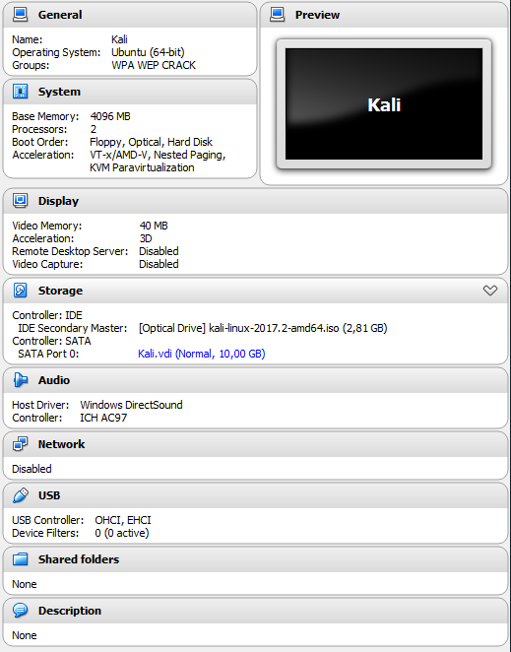

We booted KALI-vm and attached the usb adapter:

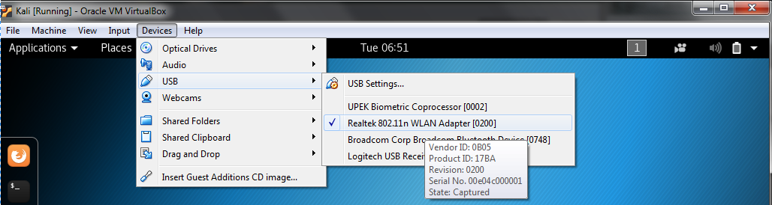

We had a laptop on the targeted network and the laptop had a ubuntu CLIENT-vm running on nat network, to make some traffic:

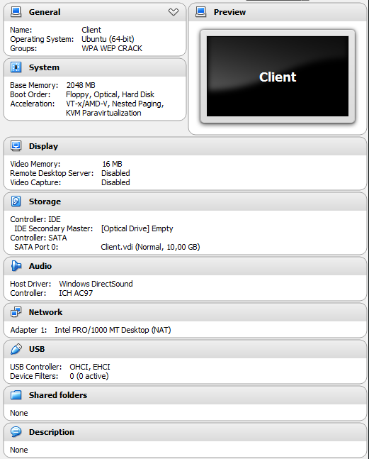

We configured two separed virtual WLAN on Mikaels router the other one was WEP encrypted and the second was WPA encrypted:

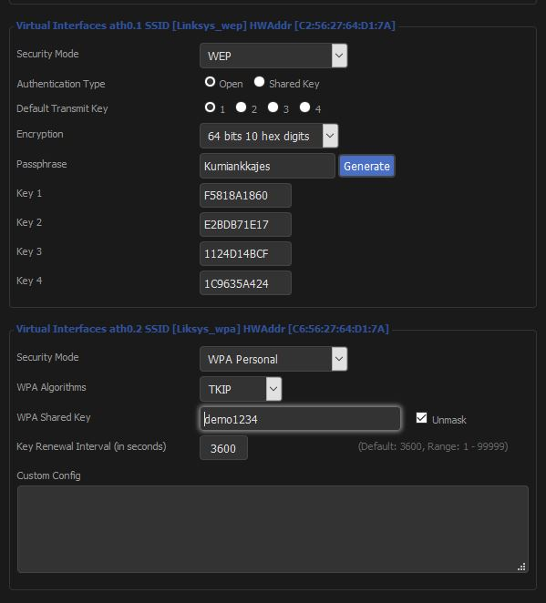

We added some extra rules to the these networks since they were extremely vulnerable, and we didn’t want anyone to do something like downloading torrent if they had access to the network:

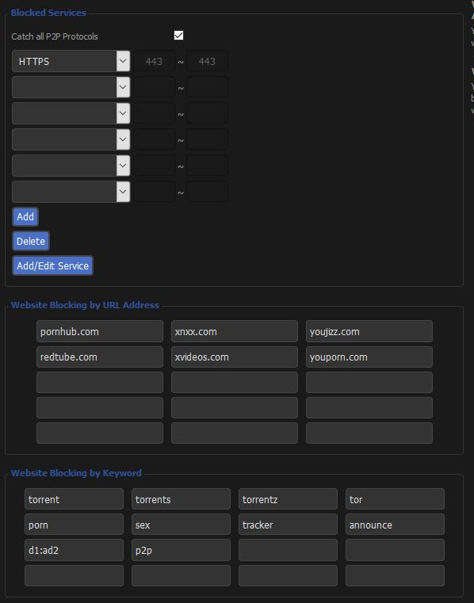

We booted up the client:

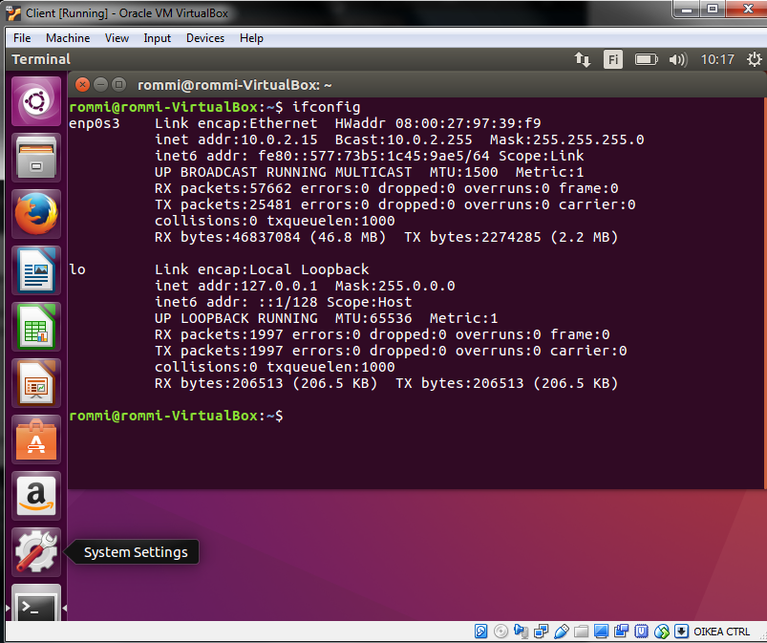

WEP:

First we checked if the usb dongle was blocked or not (it wasn’t) then we started it in the monitoring mode:

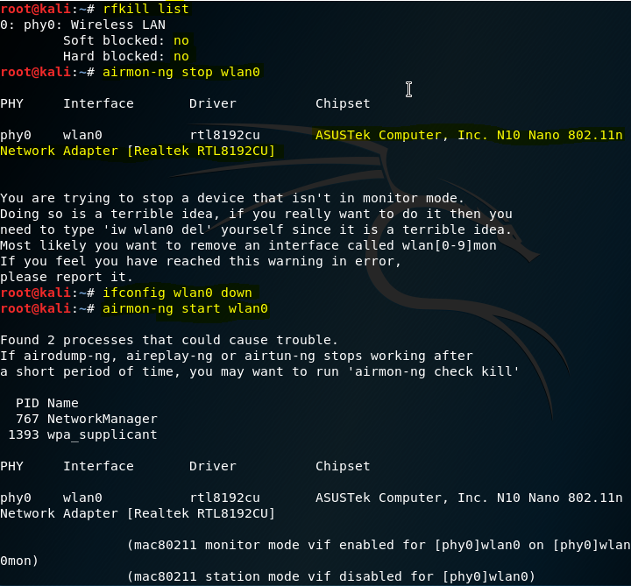

We double checked that the wlan0 dongle was on monitoring mode:

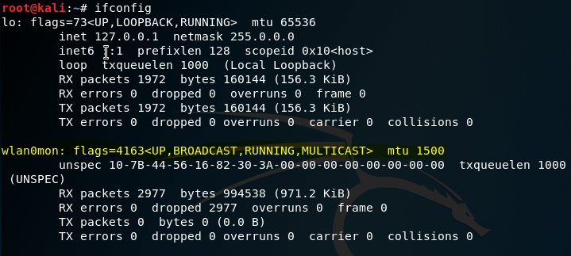

Then we started monitoring for targets (in this example we named the targets to Linksys_wep and Liksys_wpa) command inputted was *airodump-ng wlan0mon :*

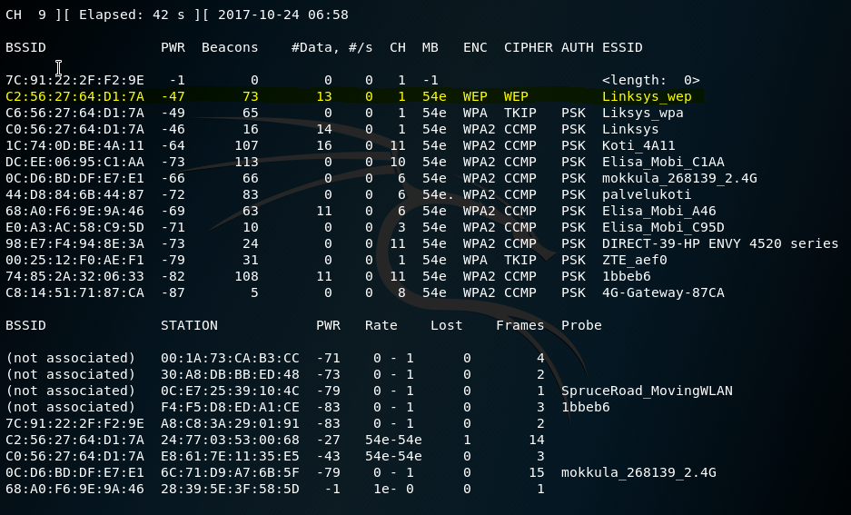

We found our target so we started capturing the traffic, our target was on channel 1 and its BSSID was C2:56:27:64:D1:7A captured file was named wepwifi and used interface to listen traffic was wlan0mon(ASUS nano n10)

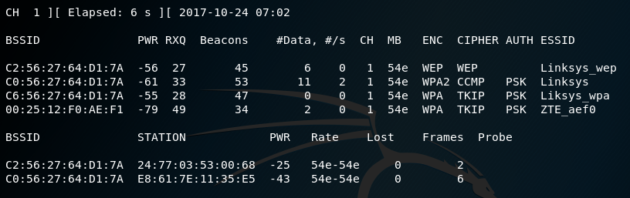

Then we fake authenticated to the accesspoint which was reauthenticated (-1) 6000 in seconds , (-o) sent only one packet at a time and send packets every tenth second (-q) -e is the target ESSID and -a target BSSID(MAC) and monitored on wlan0mon

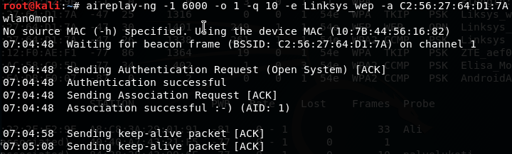

Then we started arp replay attack the (-3) means standard arp request replay and (-b) standsfor accesspoints mac address and the interface we use for capture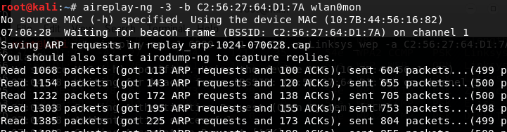

We captured a lot of packets, we generated speeded up the process by generating more packets on the CLIENT-vm:

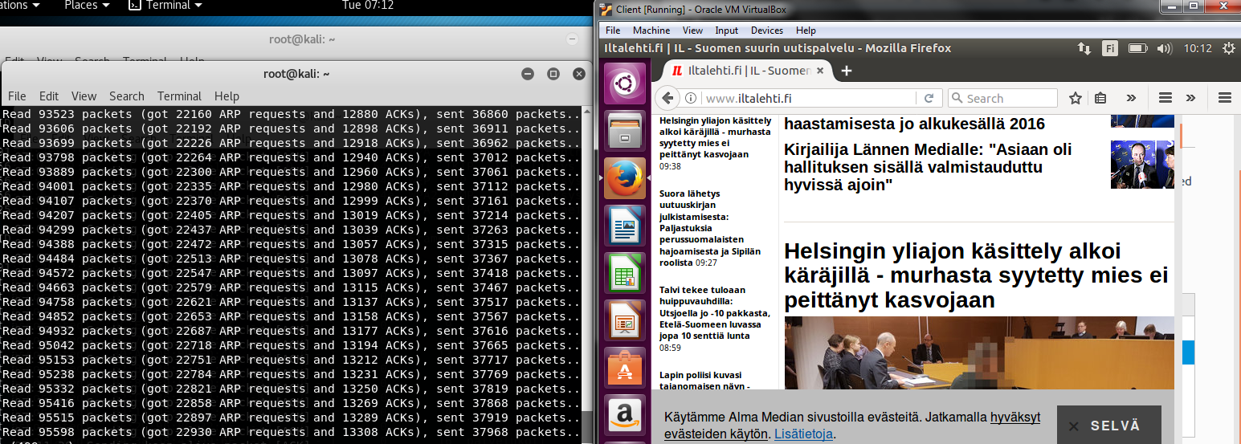

After that we tried cracking the password with our capture file

And succeeded in it: 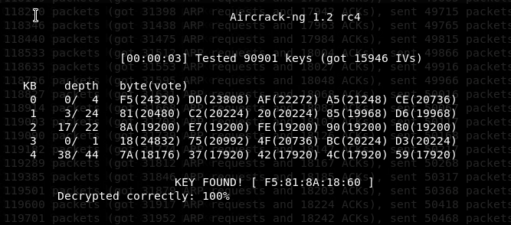

Then we stopped all the processes and tested if it worked:

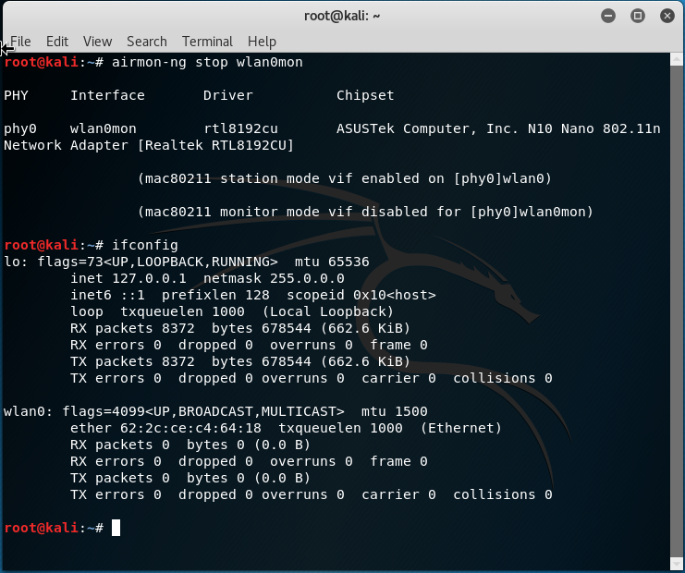

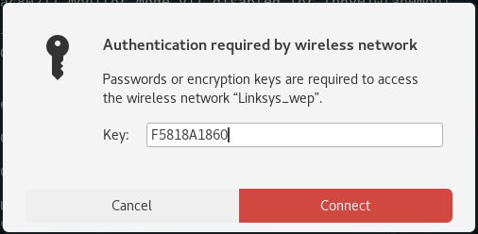

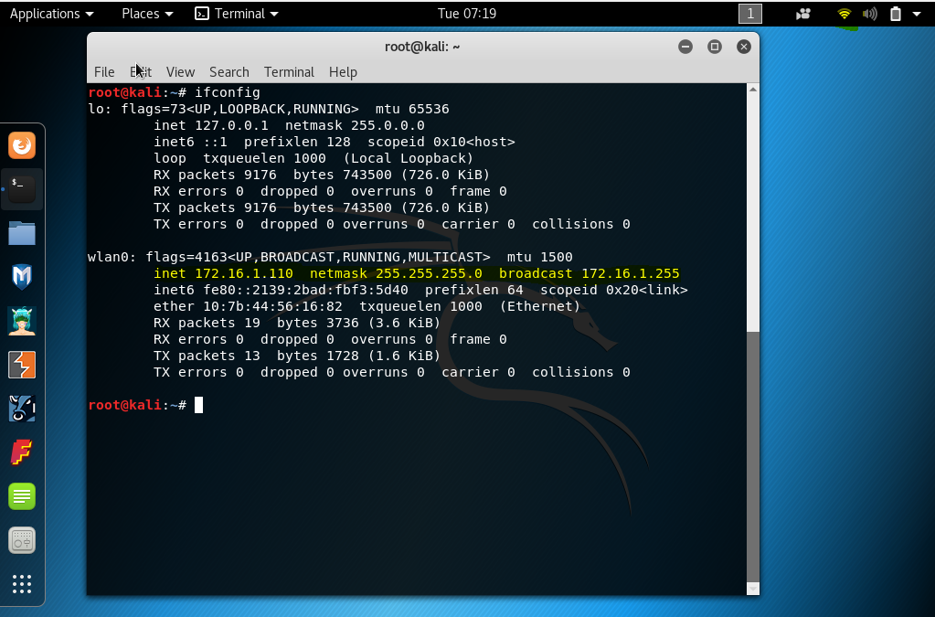

And tested if the CLIENT could reach the attacker:

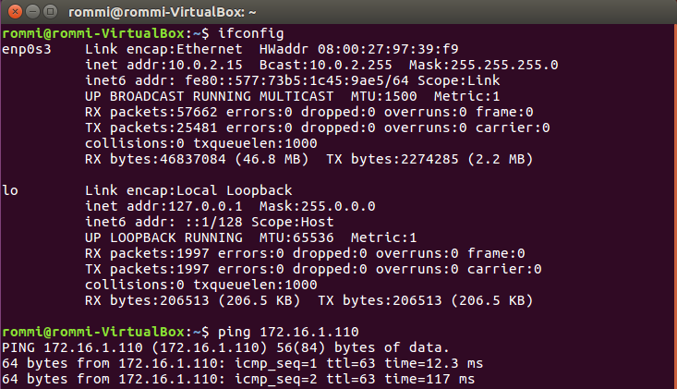

SUCCESFUL ATTACK !

WPA:

Before we started doing anything we unzipped a wordlist and sorted and got rid of duplicates and used the pw-inspector to inspect the password file for valid password inpus. Everything was dumped to a textfile named wpa.txt (which was extremely large) and we checked that our targets password was there.

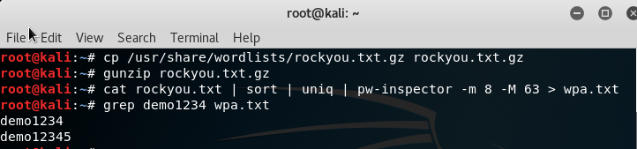

Then we did the same commands as on the WEP attack first screenshot, but we spoofed our mac address

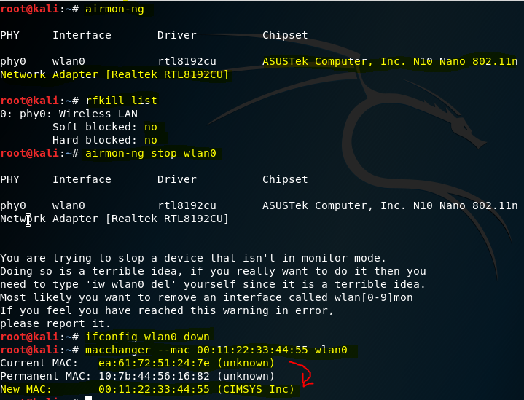

Then we started our usb dongle in monitoring mode:

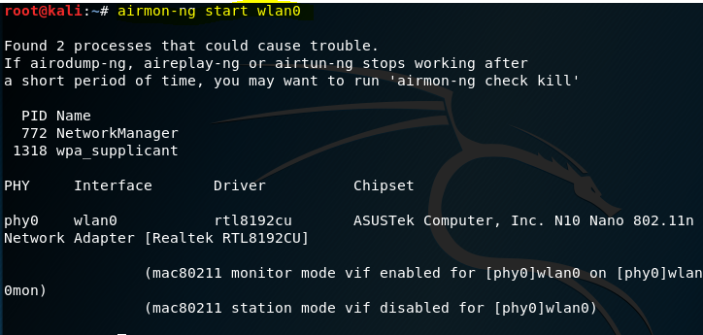

Then we searched for our target which name was Linksys_wpa, that runned on channel 1 and its MAC was C6:56:27:64:D1:7A

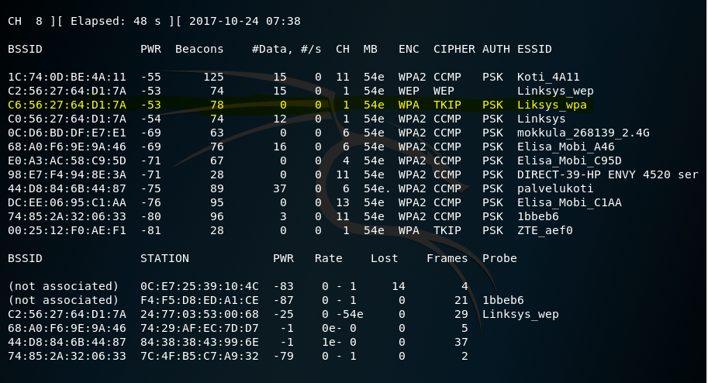Then we started capturing the target on channel 1 the file name was wpawifi.



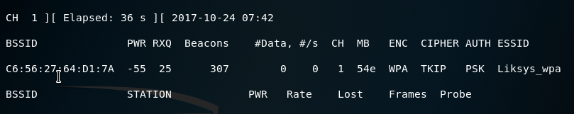

We captured the WPA handshake by forcing client to reauthenticate to the access point:

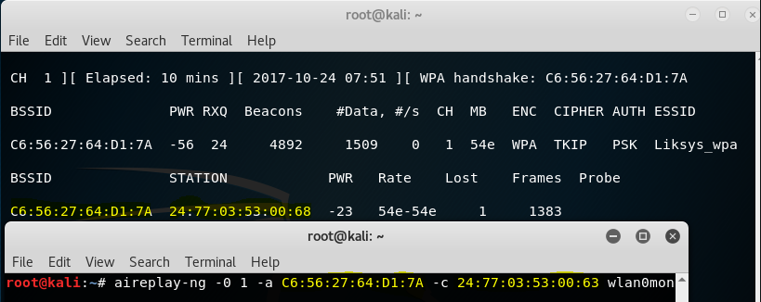

And we got the handshake:

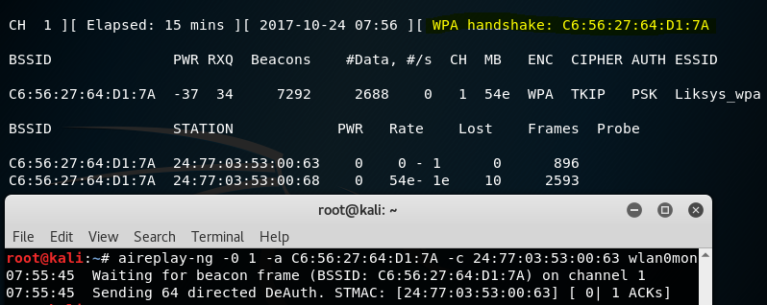

Then we started bruteforcign (using the wordlist we created earlier) We used targets ESSID, our passwordlist was wpa.txt and our capture file which contained the handshake:

We waited the crunching (should’ve put more cores to use)

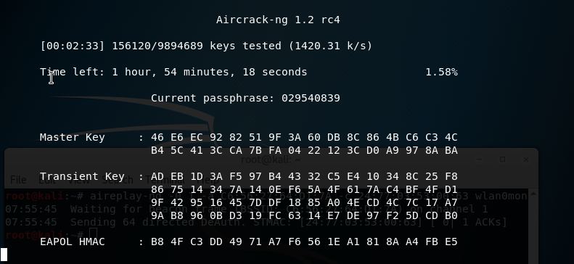

After a long wait we found the password:

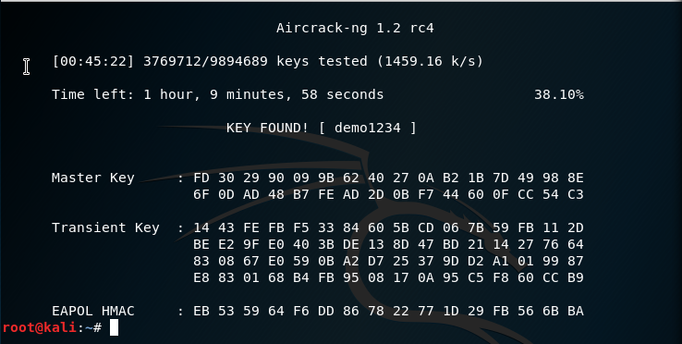

Then we tested same thing but with john the ripper. We edited the wpa.txt and modified it: 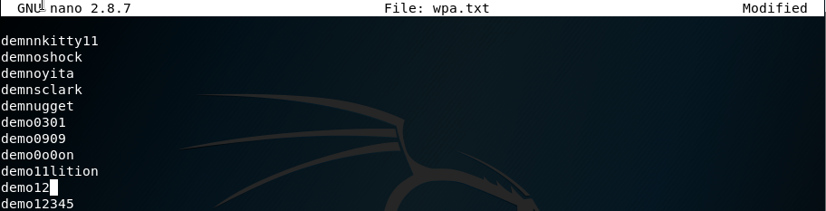

Then excluded all other wordlist parameters from john the rippers conf and added our own parameters which add 2 digits on the left or right side on given password:

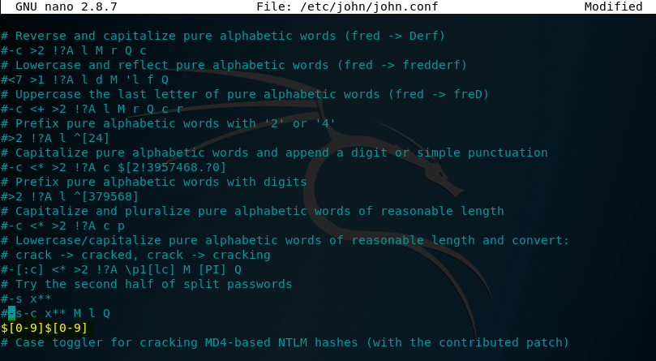

We tested the attacking with john the ripper: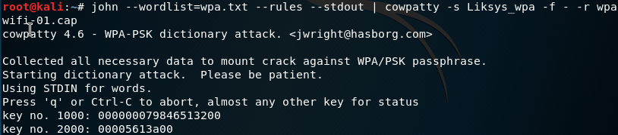After 6 hours of waiting we got bored so (we had only 2 cores in use of 16). For this example we decided to generate our own wordlist using crunch, it was variation of all the possible outcomes of demo12 from 4 to 6 characters:

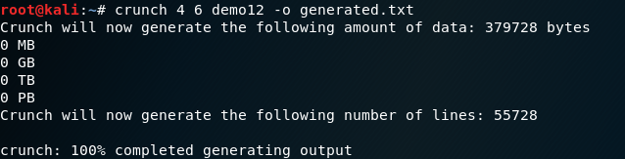

Then we started the attack with john the ripper:



We waited about 40 minutes or so and the output was:

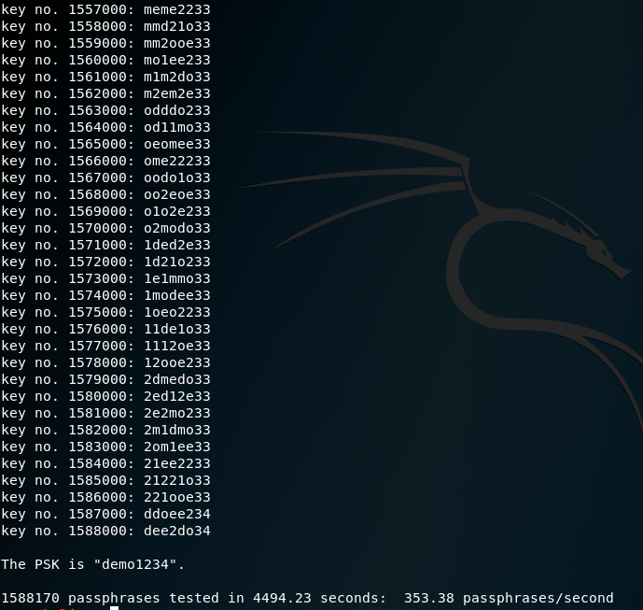

SUCCESFUL ATTACK!

* 1. What is WEP initialization vector's role in the WEP cracking?

WEP uses static encryption keys.

The WEP encryption uses a 24 bit initializing vector which meant that it reused the same initializing vector with the key and was easily cracked. When packed injection was used it was merely seconds that the key could be cracked.

* 1. How does WPA tackle the WEP’s initialization vestor’s weakness

WPA uses TKIP (temporal key integrity protocol) , which means it uses to generate a unique encryption key for each wireless client. The keys are constantly changed. Also the key size is larger than in WEP. WPA key size is 256-bit which leads to a smaller reuse of the same initializing vector.

# IPSec

We used a very simple config where we used a preshared key to authenticate to the server, since our try with a certificate failed so many times.

Installing:

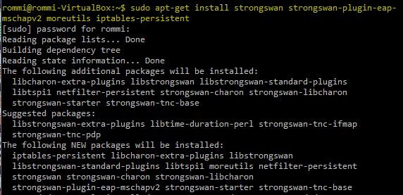

Ipsec client:

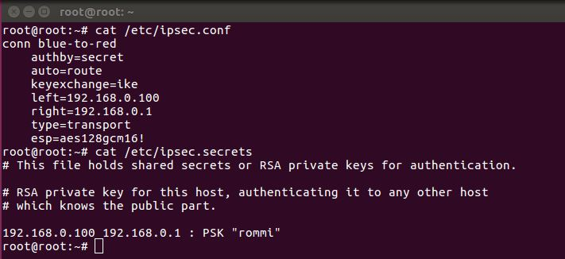

Ipsec server:

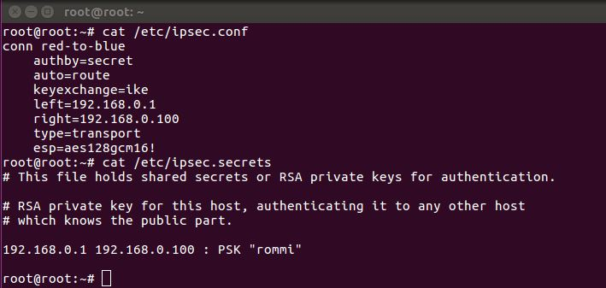

Ipsec status:

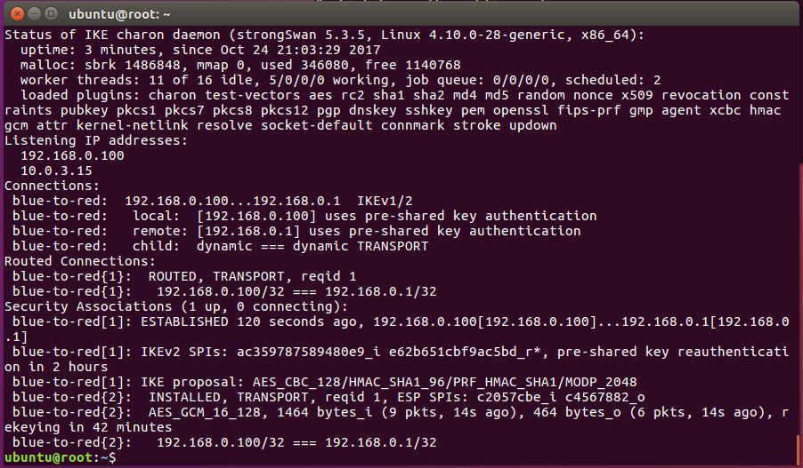

We captured traffic with wireshark when client was pinging server to see if the traffic is tunnelled. As the capture shows the traffic is tunnelled through:

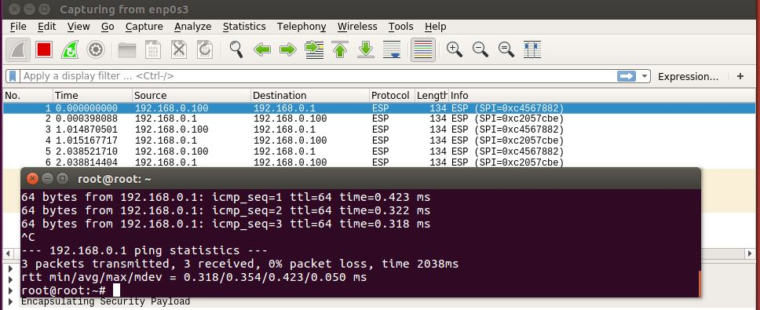

On CLIENT-vm when ipsec is not running.

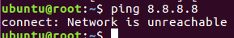

# General comments about assignment

The assignment was really interesting, we learned how to attack a vulnerable access point, generating wordlist and lot of other useful tricks. The most tedious part of the assignment was to wait for the john the ripper, it took waaaaaaaay too much time. Although in real life it takes a long time if the worldlist in use is big, but we had too little resources in use to crunch fast.

The Strongswan was hard to configure. We did a minimal version as possible since, we tried to configure vpn to work with certificates, but no go it didn’t work. After a long a rocky road we decided to make a simple PSK implementation.